BSYS 4005 - Jeff Sawers

Case Study #1 Helpful hints and tips
Input Example | Output Example
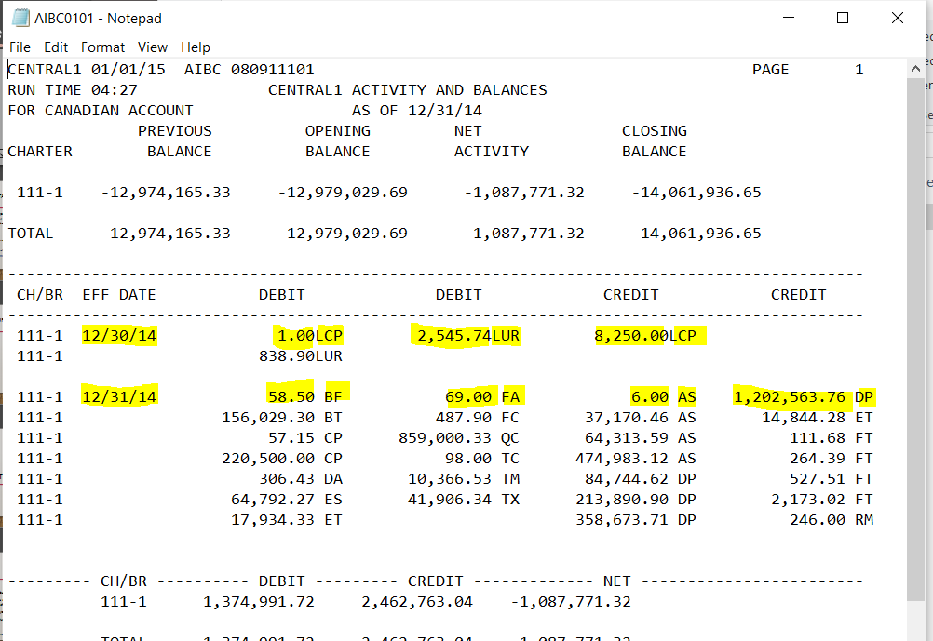 | 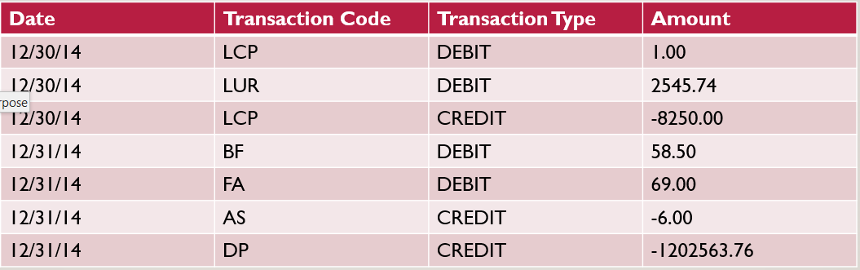

- The date can repeat itself in multiple sections (and have more than one date on a text file)
- The debit and credit columns appear at the top to define the + / - value
- The transaction codes appear more than once (you can choose to repeat or add these together if they are in the same day)
- A lot of the data in the text file can be ignored – use tools to try to filter out what you don’t need first
- Recommend using either Power Query in Excel or Python with the REGEX tools (https://regex101.com/ is a good resource)
- You may each want to try ideas and then just submit ONE best solution between your group to learn from each other
- Do not start transforming data until you really understand the individual file structure (open up many files and make notes)
- If using Power Query, switch to fixed width view, and at some point the unpivot function will be needed
- Avoid hard coding for specific examples – an excellent solution will scale to other files you will not see
- Your output format must match the sample given

